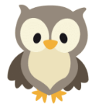
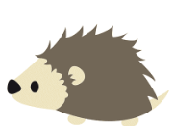
Week of the 20th June – 24th June 2022
Bluebell Wood Bulletin

Our Year Two Team:
Owl class – Mrs Lewis (Monday to Thursday) and Mrs Davies (Friday), Miss Brooks, Mrs Phillips and Mrs Patel.

Hedgehog class – Mrs Turner (Monday, Tuesday and Friday) and Mrs Davies (Wednesday and Thursday), Mrs Brooks, Mrs Kaushal and Mrs Patel.
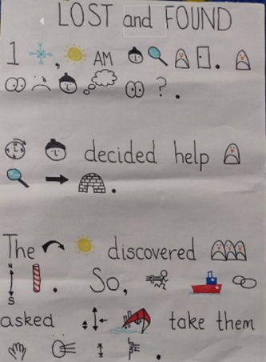
English:
This week we have been learning our text ‘Lost and Found’ by Oliver Jeffers. We have been creating our own actions for our TFW and writing the story in our books.

Science:
In science we learnt about microhabitats. We went searching under rocks, pots and other microhabitats in the school grounds and found lots of different minibeasts. We saw woodlice, slugs, ants, spiders, ladybirds, ladybird larvae and many bees on the lavender. Some of Hedgehog class even saw an oil beetle briefly!
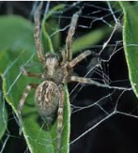
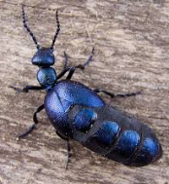
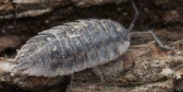
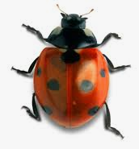
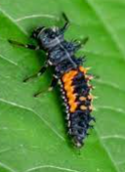
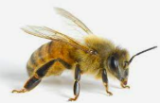

Maths:
This week in maths we have been looking at position and direction. We have been describing and recording movements. Next week we will be looking at turns using the vocabulary clockwise and anticlockwise.
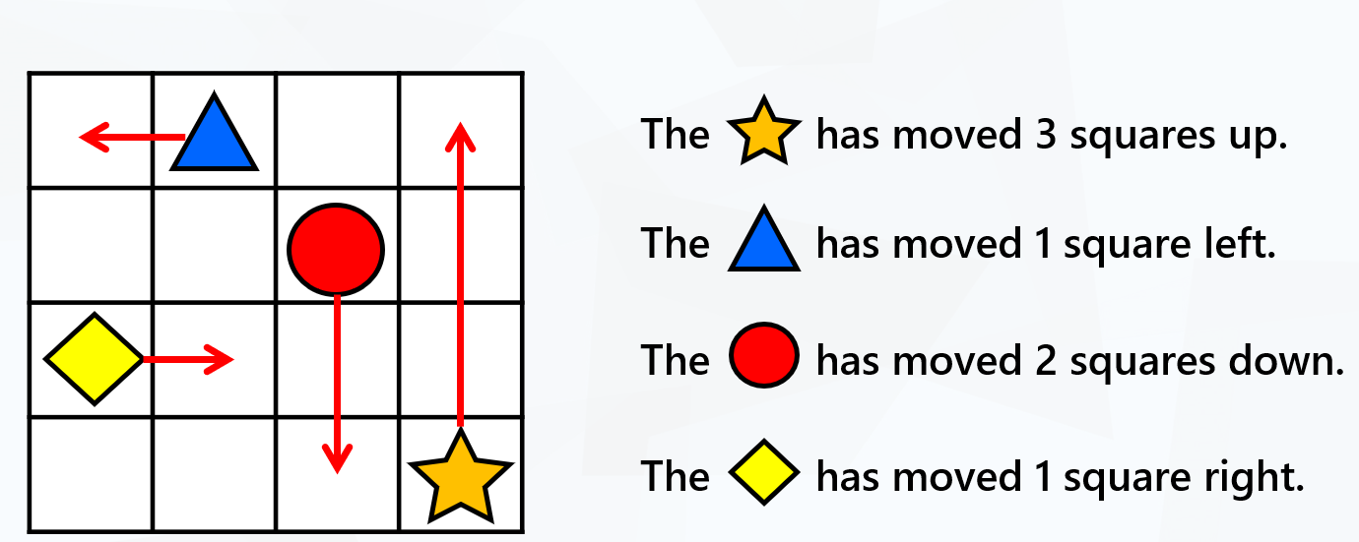

Reading books:
Just to remind you that your child will have a set day to change their books. If they are on Read Write Inc (RWI) books they will take home one RWI book to read and two Oxford Reading Tree books to share. When an adult listens to your child read 1:1, it will be recorded in their reading record. Every child participates in a daily storybook lesson but this will not be recorded in their reading record.

Please ensure books bags are brought into school and reading records filled in for any reading done at home. Please listen to your child read at least three times a week.

If you, or anyone you know of, would be able to regularly volunteer to come in one afternoon and read with the children we would love to hear from you.

Please remember:
- Please make sure your child has a named water bottle in school.

- Please remember to make sure your child is wearing sun cream and brings a named hat to school.

- Year Two PE days are Monday and Wednesday. Please can your child come into school wearing the Willow Bank PE kit.

- Children should all have received a letter for our trip to Beale Park on the 14th of July. Please return the permission slip and medical form in a named envelope. Payment can be sent into the school fund account.

- As part of our Art this term we will be making shoebox habitats. We would be grateful if you send in any spare shoeboxes you might have.

- At the end of term the children will be bringing home all their books and wall display works of art. Again, we would be ever so grateful if you could send in any plastic bags for work to go home in.

