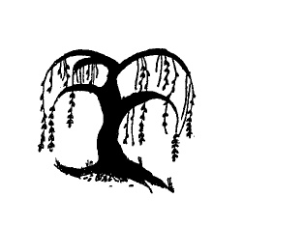

Literacy

Labels, list and captions
Using story maps to retell stories
Guided write sessions
focusing on applying segmenting skills focusing on sentences and using finger spaces.

Hold a sentence, say what you want to write before writing.

Writing sentences linking to focus text and role -play
Writing recounts
Spring Poems
Reading and phonics
To understand what they have read
To continue with the set 1 and set 2 sounds.
To develop fluency when reading.

Maths
Number 9 and 10, making 9 and 10 using a tens frame.
Number: Comparing numbers to 10.
Number: Adding 2 groups, using a number line
Number: Making 10
Sorting and matching 3D shapes
Exploring more complex patterns
Consolidate learning and understanding

Communication and Language

Retell a story using story language
Listening and attention skills

Uses language to imagine and recreate roles and experiences in play situations.

Builds up vocabulary that reflects the breadth of their experiences

Year Group: Foundation Stage
Term: Spring 2 2022
Physical Development

Dance
Healthy eating

Fine motor activities
Getting changed independently

Taking risks and developing gross motor skills using outside equipment

Expressive Arts and Design

Dramatic role play opportunities
Role play a doctor’s surgery
Fire station
Junk modelling – construct with a purpose in mind.
Observational drawings
Making Easter and Mother day cards
Experiment with different printing and art techniques ((marbles, straws, printing with a variety of tools)

Understanding the World

Exploring the jobs that people in our community do.
To identify where doctors and nurses work.
What does a police officer do?
What does a firefighter do?
What does a midwife do?

Signs of spring- making observations
Easter traditions. How is Easter celebrated?
Mother day traditions.

Shows an interest in ICT.

Completing different games/activities on a computer /I pad

Willow Bank Infant School
Personal Social Emotional Development
Gem power,
Diamond power- independence
Ruby power- being helpful and showing kindness.
Who helps us at home and school?
What happens when we are sick?
How can we keep healthy?
Keeping safe – fire safety
Growth mindset- What makes us a good learner?
People Who Help Us and Spring

