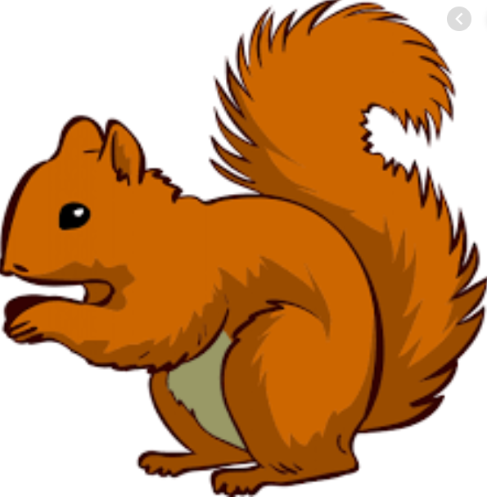
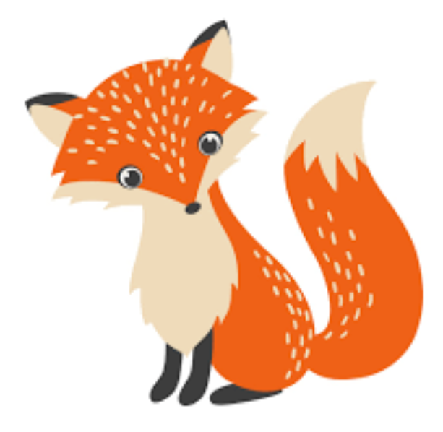
Week Beginning Monday 18 July 2022
Year 1 Bulletin
Fox Class Staff:
Miss Clift – Class Teacher
Mrs Smith and Mrs Hurst – Teaching Assistants
Misss O’Reilly and Mrs Dobson – 1:1 Teaching Assistants

Squirrel Class Staff:
Mrs Atkinson - Class Teacher
Mrs Draper and Mrs McDonald - Teaching Assistants
Mrs Singh and Mrs Drummond - 1:1 Teaching Assistants
Support teacher- Mrs Leviss – Qualified Teacher, teaching across both classes

Dates for the Diary-

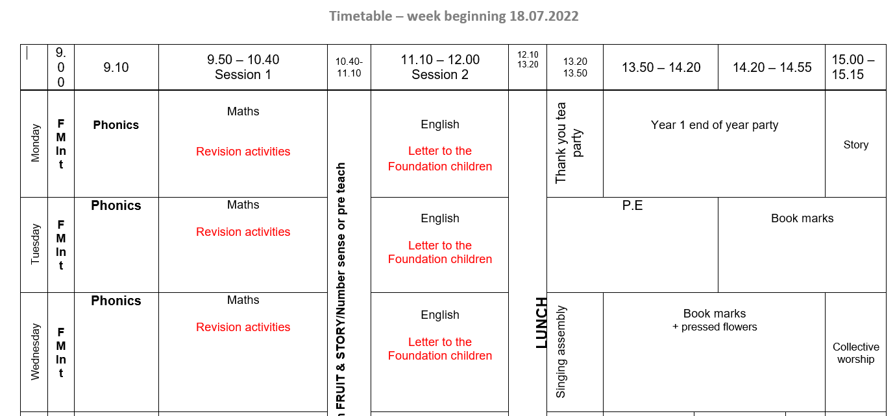
18.7.22
Class parties (Afternoon) – please send children in with a snack for themselves and a drink.

5.9.22 – Return to school as Year 2s! Both Hedgehogs and Owls to enter school through Hedgehogs door.

Weekly Timetable
We thought it might be useful for parents to have the weekly timetable so you can talk to your children about what they have been learning that day. You might ask them questions like “what did you find out about in History today?” “what did you make in Art today?”

Thank You!
Thank you very much for all your support this year. We have had a fabulous year together and we couldn’t do it without your support! It has been lovely to see you at whole school events such as Sports Day and our Jubilee Picnic. We look forward to sharing more events with you next year!

English
In English we will be writing letters to Foundation Children to tell them all about what they need to know for Year 1. You could talk to your children about their learning this year. You could say “How did you use Gem Power in Year 1?” “What was your favourite story that you shared?” or “What did you learn about number and shapes?” “What did you learn about the world in Geography?” or “What experiments, plants or animals do you remember from Science?”
Maths

In Maths we will be solving problems and applying the skills from Year 1. For example-
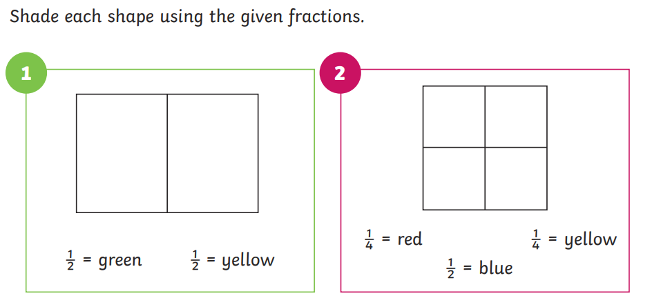
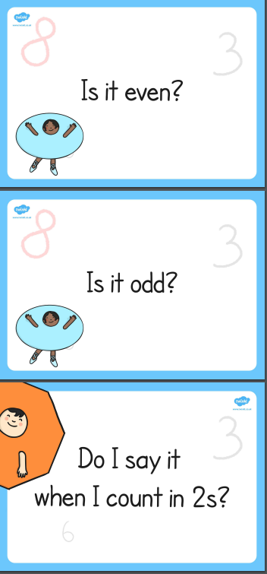
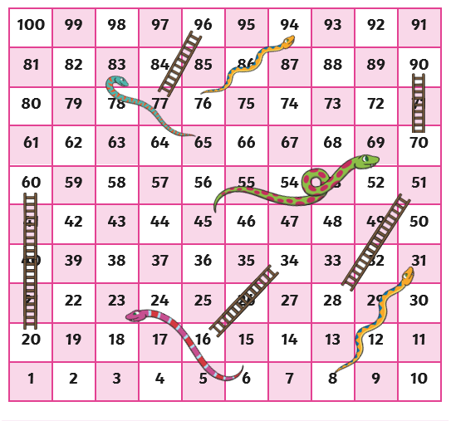

Reading

*All reading books are being collected in. If you have any reading books at home please send them in with your child before the end of the term.
Helping at home – anything you do at home can be a challenge! Think about ways of counting numbers in the local environment, looking at road signs, door numbers and writing holiday news to friends and family! Remember to share lots of reading books too. There is the Summer Reading Challenge which you can participate in through the library. Have a wonderful Summer and we look forward to seeing you all in September.
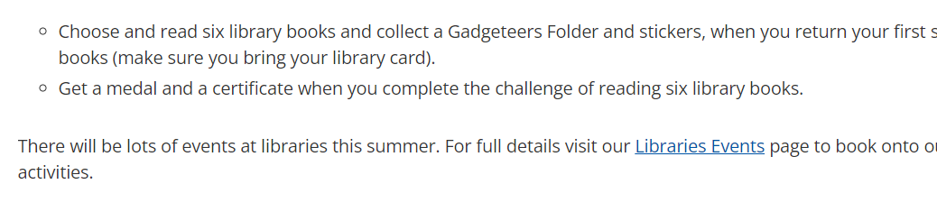
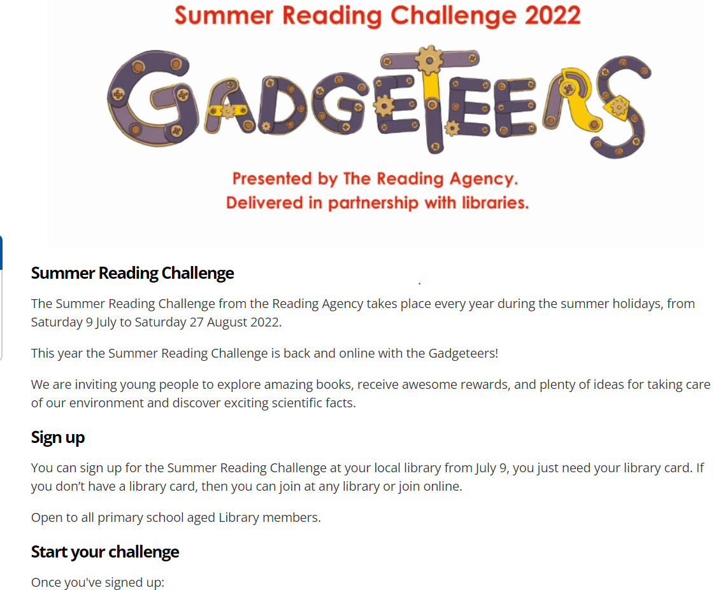

The children in year 1 now all have logins for purple mash. Please log into your child’s account and have an explore of the games and activities available to use. You will find their log in details in their reading record book.
https://2simple.com/purple-mash/
Please Remember –
- Children come in PE kit on Tuesdays and Thursdays.
- They will need a bag of spare clothes to keep on their peg.
- Please make sure your child has a named water bottle in school.
- Please return any library books in their library folders.

Many thanks for your support, The Year 1 Team

