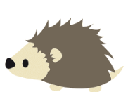
Week of the 16th May – 20th May 2022
Bluebell Wood Bulletin

Our Year Two Team:
Owl class – Mrs Lewis (Monday to Thursday) and Mrs Davies (Friday), Miss Brooks, Mrs Phillips and Mrs Patel.

Hedgehog class – Mrs Turner (Monday, Tuesday and Friday) and Mrs Davies (Wednesday and Thursday), Mrs Brooks, Mrs Kaushal and Mrs Patel.

Wow! What a busy half term we have had! This week the children enjoyed the Woodley sports session and a country dancing lesson. We hope you all have a lovely half term.

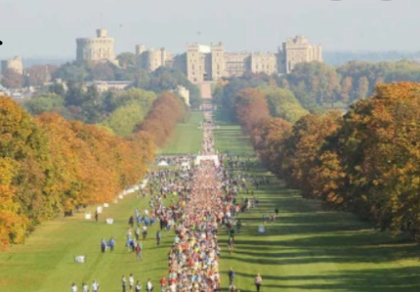
English:
This week we learnt about the Queen’s Platinum Jubilee Celebrations and wrote a poster persuading people to attend the celebrations in Windsor.

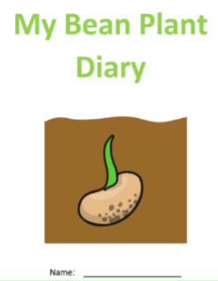
Science:
In science we have been observing our beans we planted and have recorded our findings in our Bean Diary. We will be sending the beans home and we hope the children enjoying caring for them and watching them grow.

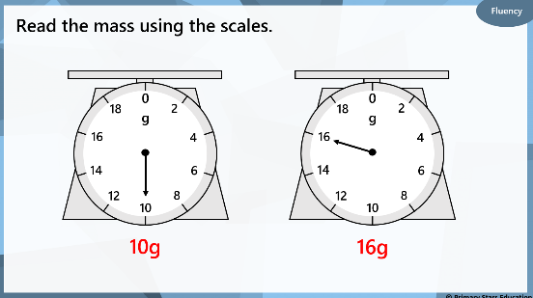
Maths:
This week in maths we have been learning about mass. We have been making predictions about and comparing the mass of two objects. We have been weighing objects in grams and learning to read scales.

Reading books:
Just to remind you that your child will have a set day that they are listened to read and are able to change their books. If they are on Read Write Inc (RWI) books they will take home one RWI book to read and two Oxford Reading Tree books to share. When an adult listens to your child read 1:1, it will be recorded in their reading record. Every child participates in a daily storybook lesson but this will not be recorded in their reading record.

Please ensure books bags are brought into school and reading records filled in for any reading done at home. Please listen to your child read at least three times a week.

If you, or anyone you know of, would be able to regularly volunteer to come in one afternoon and read with the children we would love to hear from you.

R.E:
In R.E on Wednesday 8th June we will be talking about our prized possessions. Please can the children bring in something that is important to them, small enough to keep in their tray. If their special object is too big, can they bring a photo of the object. The rule will be that no one can look or touch anyone else's possession that day.

Please remember:
- Please make sure your child has a named water bottle in school.

- Please remember to make sure your child is wearing sun cream and brings a named hat to school.

- Year Two PE days are Monday and Wednesday. Please can your child come into school wearing the Willow Bank PE kit.

