Week of the 16th May – 20th May 2022
Bluebell Wood Bulletin

Our Year Two Team:
Owl class – Mrs Lewis (Monday to Thursday) and Mrs Davies (Friday), Miss Brooks, Mrs Phillips and Mrs Patel.

Hedgehog class – Mrs Turner (Monday, Tuesday and Friday) and Mrs Davies (Wednesday and Thursday), Mrs Brooks, Mrs Kaushal and Mrs Patel.

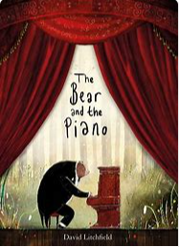
We were all very disappointed that our Jubilee picnic could not take place but the children enjoyed their indoor picnic and have had a lovely day creating Queen portraits in the classroom. We hope you enjoy the pictures.

English:
This week we have written our own imaginary tale based on the story ‘The Bear and Piano’ which we have been learning. The children were using noun phrases, contractions, adverbs and adjectives.

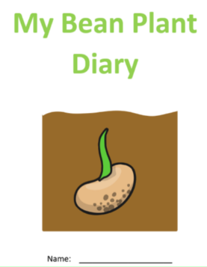
Science:
In science we have been observing our beans we planted and have recorded our findings in our Bean Diary.

Reading books:
Just to remind you that your child will have a set day that they are listened to read and are able to change their books. If they are on Read Write Inc (RWI) books they will take home one RWI book to read and two Oxford Reading Tree books to share. When an adult listens to your child read 1:1, it will be recorded in their reading record. Every child participates in a daily storybook lesson but this will not be recorded in their reading record.

Please ensure books bags are brought into school and reading records filled in for any reading done at home. Please listen to your child read at least three times a week.

If you, or anyone you know of, would be able to regularly volunteer to come in one afternoon and read with the children we would love to hear from you.

Please remember:
- Please make sure your child has a named water bottle in school.

- Year Two PE days are Monday and Wednesday. Please can your child come into school wearing the Willow Bank PE kit.

- On Monday the 23rd of May we will be going to Woodford Park as part of Woodley Sports week. Please can all children meet at Woodford Park at 9 o clock where a member of staff will meet them. Children will need to be in PE kit and have a water bottle and snack for the morning. If a school dinner has not already been ordered, children will need to bring a pack lunch with them.

- Next Thursday 26th May we have a country dancing workshop in school. Please can your child come to school in their PE kit that day.
