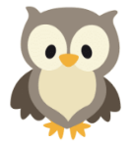
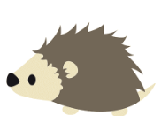
Week of the 11th July – 2022
Bluebell Wood Bulletin

Our Year Two Team:
Owl class – Mrs Lewis (Monday to Thursday) and Mrs Davies (Friday), Miss Brooks, Mrs Phillips and Mrs Patel.

Hedgehog class – Mrs Turner (Monday, Tuesday and Friday) and Mrs Davies (Wednesday and Thursday), Mrs Brooks, Mrs Kaushal and Mrs Patel.

This week we have been busy finishing our work for the Leavers Assembly on Tuesday. We look forward to sharing it with you.

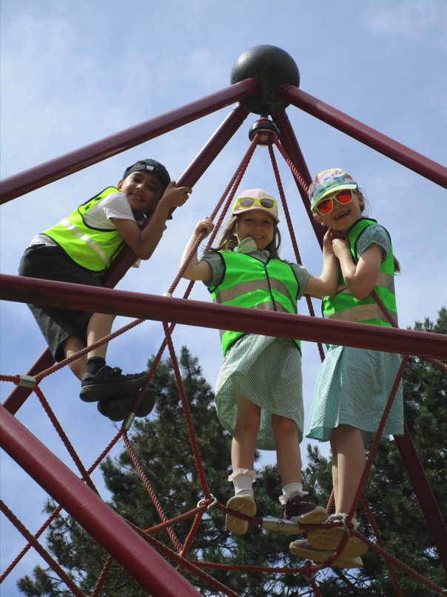
We had an absolutely fantastic time at Beale Park on Thursday and enjoyed seeing all the different animals. Some of our favourites were the meerkats, mongoose, lemurs, peacocks and zebras.

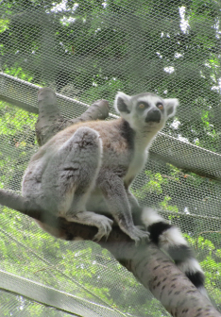
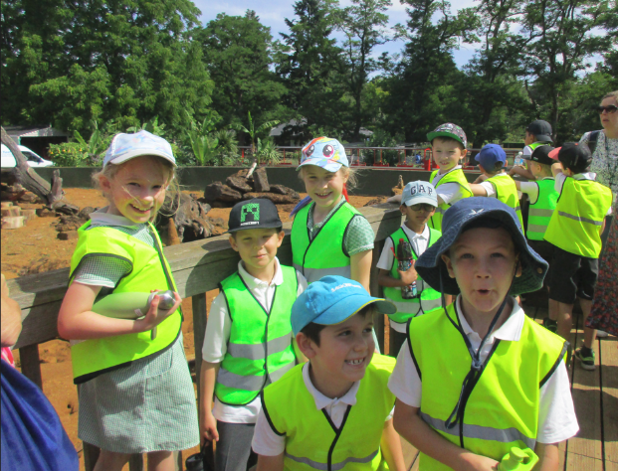

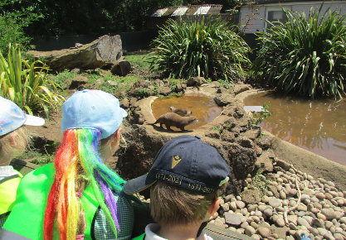
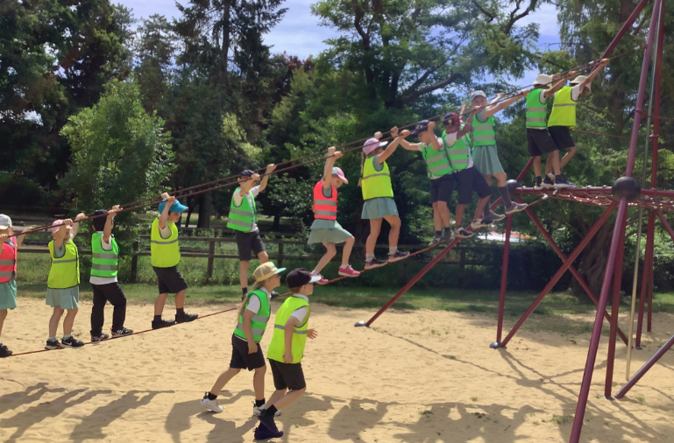

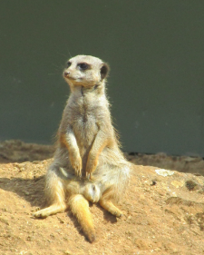

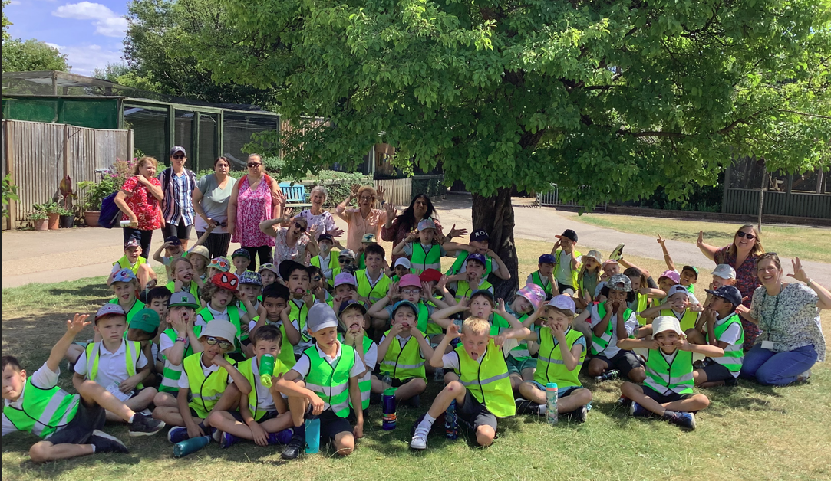

Reading books:
These have been collected in this week for sorting. Should you find any school reading books or library books at home we would be grateful if they could be returned.

Please remember:
- Please make sure your child has a named water bottle in school.

- Please remember to make sure your child is wearing sun cream and brings a named hat to school.

- Tuesday 19th July. Leavers assembly at 9:20 in the hall, we are looking forward to sharing this event with you.

- Wednesday 20th July Leavers breakfast.

.

