Week of the 9th May – 13th May 2022
Bluebell Wood Bulletin

Our Year Two Team:
Owl class – Mrs Lewis (Monday to Thursday) and Mrs Davies (Friday), Miss Brooks, Mrs Phillips and Mrs Patel.

Hedgehog class – Mrs Turner (Monday, Tuesday and Friday) and Mrs Davies (Wednesday and Thursday), Mrs Brooks, Mrs Kaushal and Mrs Patel.

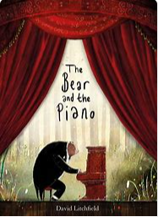
English:
This week we have been learning and retelling the story of the Bear and the Piano. Next week we will be innovating the story and writing our own version.

Maths:
This week we have been learning about measurment and have been practising accurate measuring using a ruler. We have also been using a metre rule and finding objects that are more than and less than a metre.
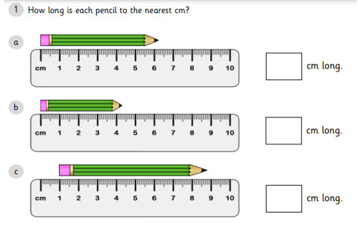

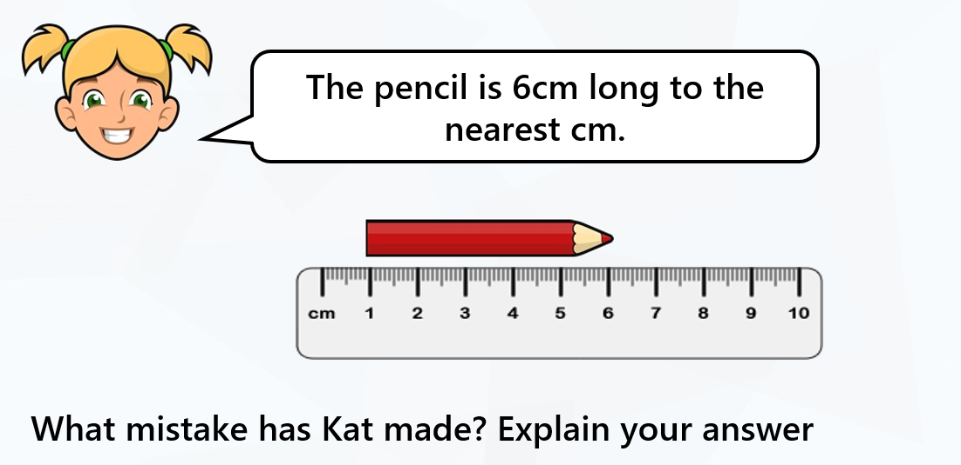

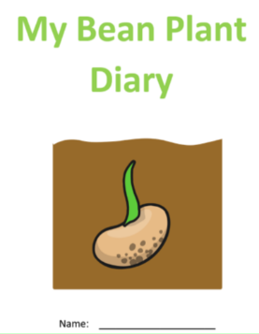
Science:
In science we have been observing our beans we planted and have recorded our findings in our Bean Diary.

Reading books:
Just to remind you that your child will have a set day that they are listened to read and are able to change their books. If they are on Read Write Inc (RWI) books they will take home one RWI book to read and two Oxford Reading Tree books to share. When an adult listens to your child read 1:1, it will be recorded in their reading record. Every child participates in a daily storybook lesson but this will not be recorded in their reading record.

Please ensure books bags are brought into school and reading records filled in for any reading done at home. Please listen to your child read at least three times a week.

If you, or anyone you know of, would be able to regularly volunteer to come in one afternoon and read with the children we would love to hear from you.

Please remember:
- Please make sure your child has a named water bottle in school.

- Year Two PE days are Monday and Wednesday. Please can your child come into school wearing the Willow Bank PE kit.

- Friday 20th Jubilee picnic. Please see parent mail for further information.

- On Monday the 23rd of May we will be going to Woodford Park as part of Woodley Sports week. A letter will be sent out with further details.

Look, Say, Cover, Write and Check!

Tick the columns as you follow the instructions from left to right. Make sure you spell the words in the ‘write’ column. If you spell the word incorrectly, write it again in the correction column.

 | look | say | cover | Write | check | correction
bear
Melody
bounded
ventured
speedily
Dreamily
Joyful
loudly

